Practical - 5
Practical Title: 5: Registration Form with Frontend Validation and User-Friendly Error Handling

Problem Definition: Create a student registration form with HTML5 input types and JavaScript validation for name, email, mobile number, password, confirm password,

course, year, gender, and terms acceptance. Use Regular Expression for

validations.

A. Theory
1. Are correct input types and attributes used?
ANSWER:
Yes, appropriate HTML5 input types is used according to the type of data being entered.
For example:
Field | Recommended HTML Input Type | Purpose
Student ID / E-mail | text | Accepts either Student ID or e-mail
Password | password | Hides password characters
Age | number | Accepts numeric age
Contact Number | tel | Suitable for phone numbers
Name | text | Accepts alphabetic/text input
E-mail | email | Provides browser-level e-mail validation

2. Are validation errors displayed near the relevant fields?
ANSWER:
Yes, in the current code, errors are displayed using JavaScript alert() messages.

3. Is password strength checked?
ANSWER:
Yes, password strength is checked using a regular expression.
Here, password validation checks for:
- Minimum 6 characters
- At least 1 uppercase letter
- At least 1 digit
- At least 2 lowercase letters

4. Is the form accessible using keyboard and screen-reader-friendly labels?
ANSWER:
Yes, it is accessible. The JavaScript provides some keyboard-friendly behavior because after an invalid input, the .focus() method moves the keyboard focus to the incorrect field.

Implementation/ Output/Result:

Evidence of Work (Screenshots):
- LOGIN PAGE:
Login Successful (after all the regex validations(for username and password)):
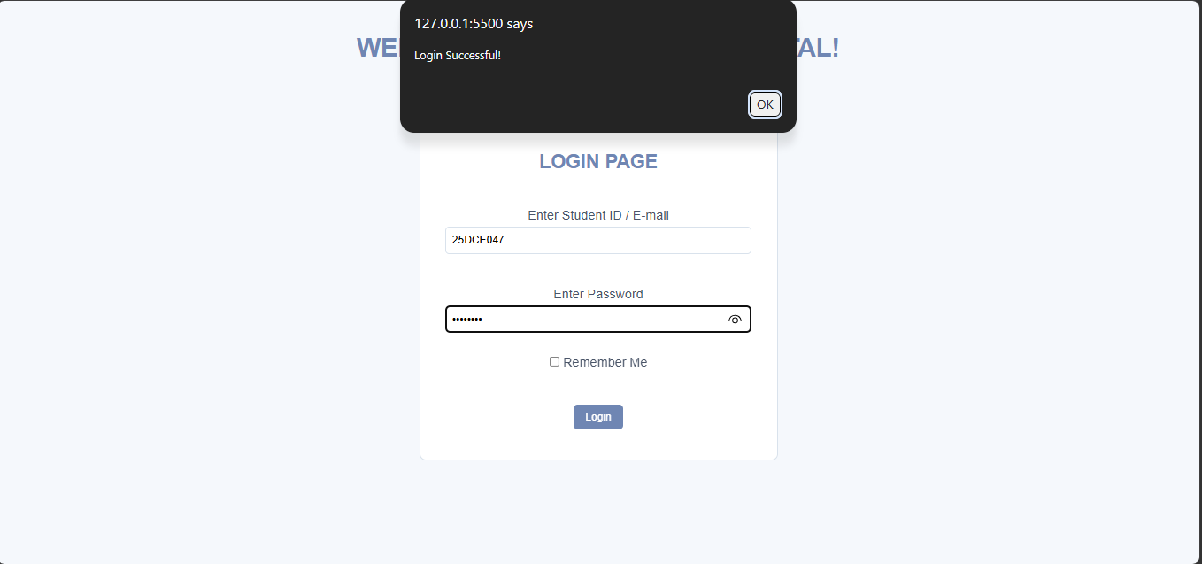

Entered invalid username:
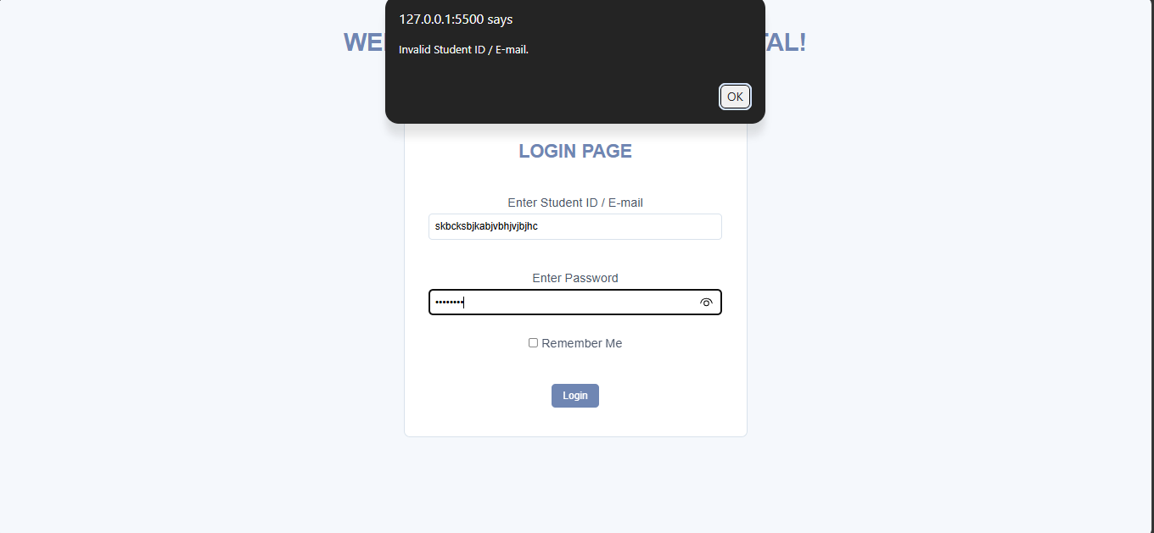

Entered inappropriate length of username:
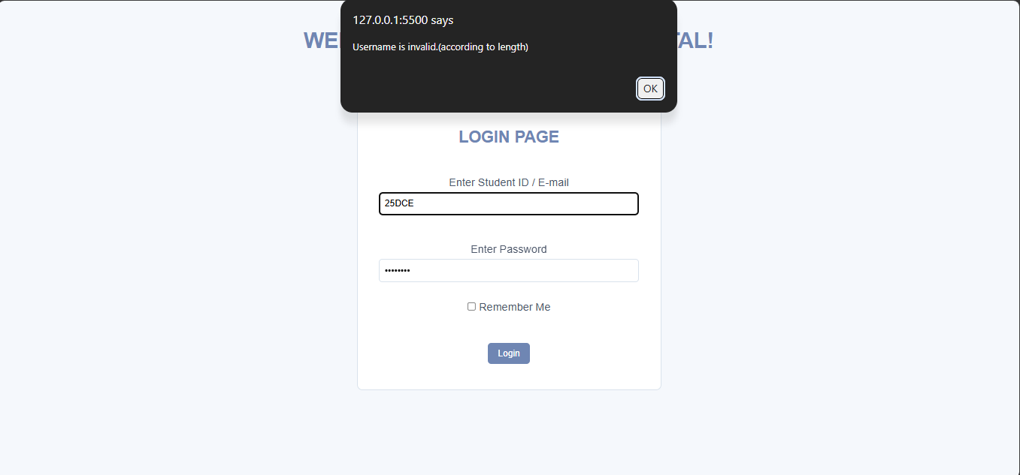

Entered invalid e-mail:
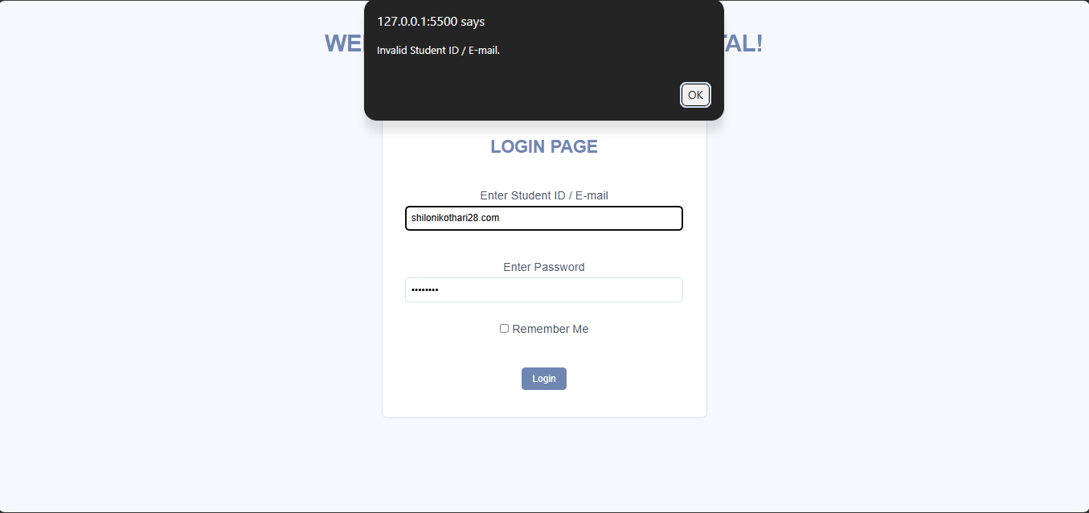

Login successful by entering valid e-mail:
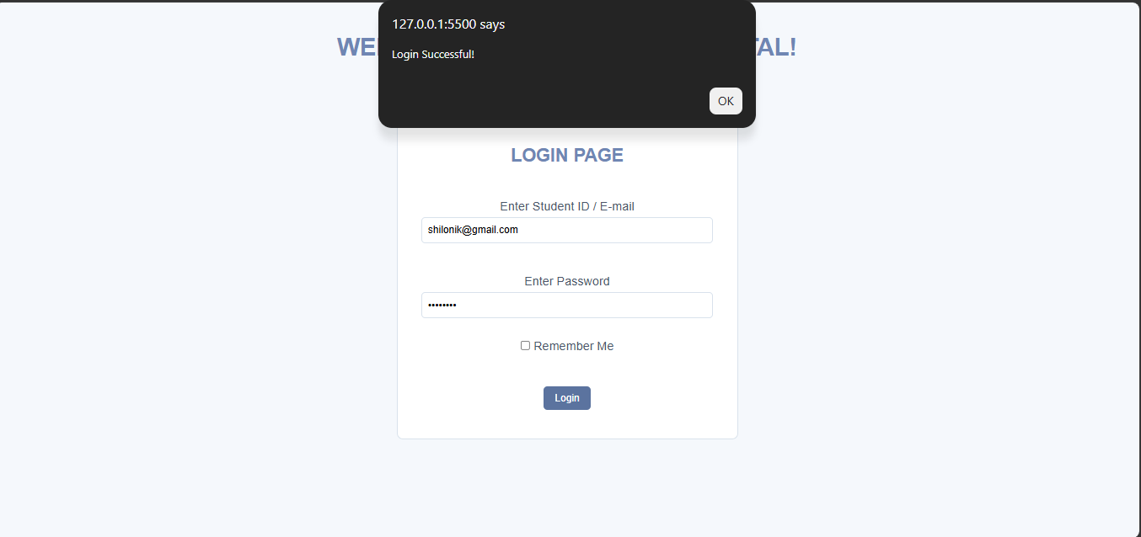

Password not according to the regex:
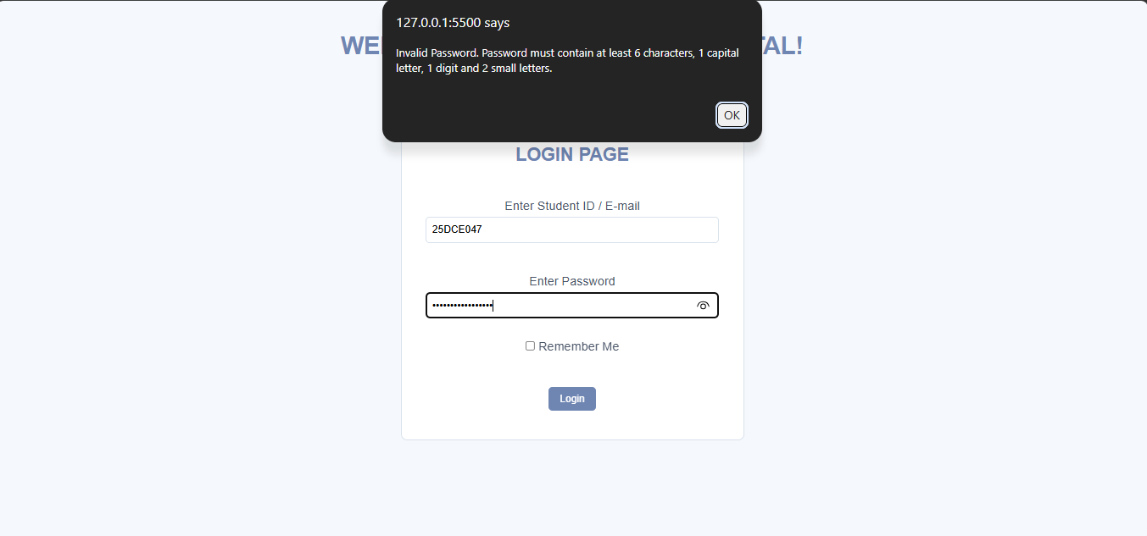

- PROFILE PAGE:

Entered invalid age:
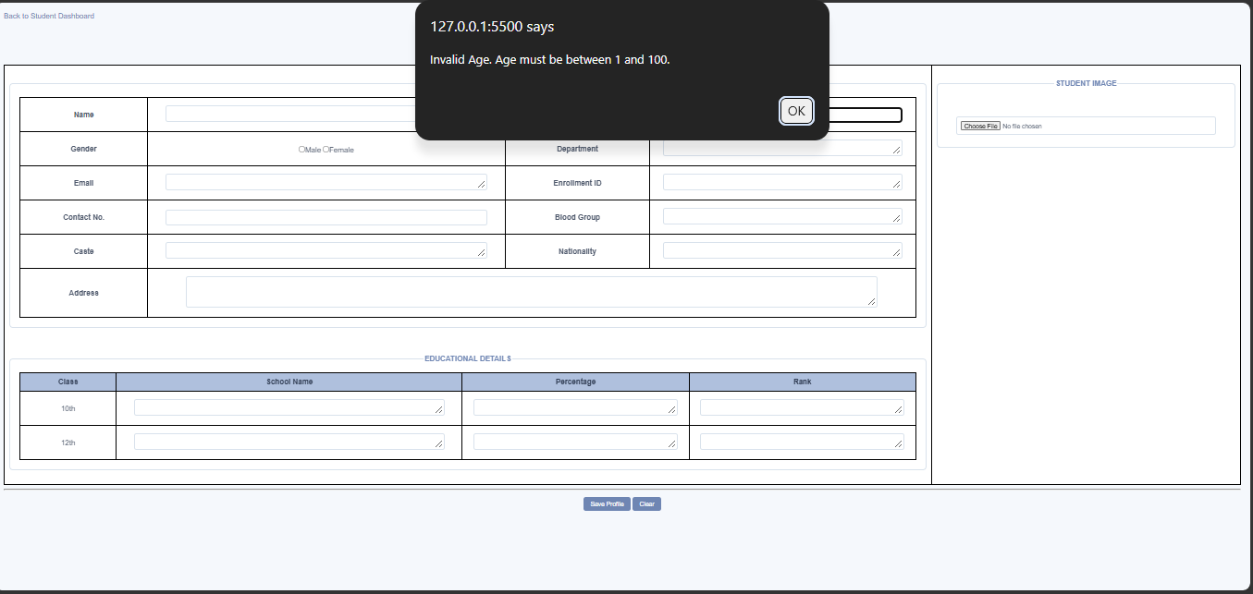

Entered invalid Contact Number:
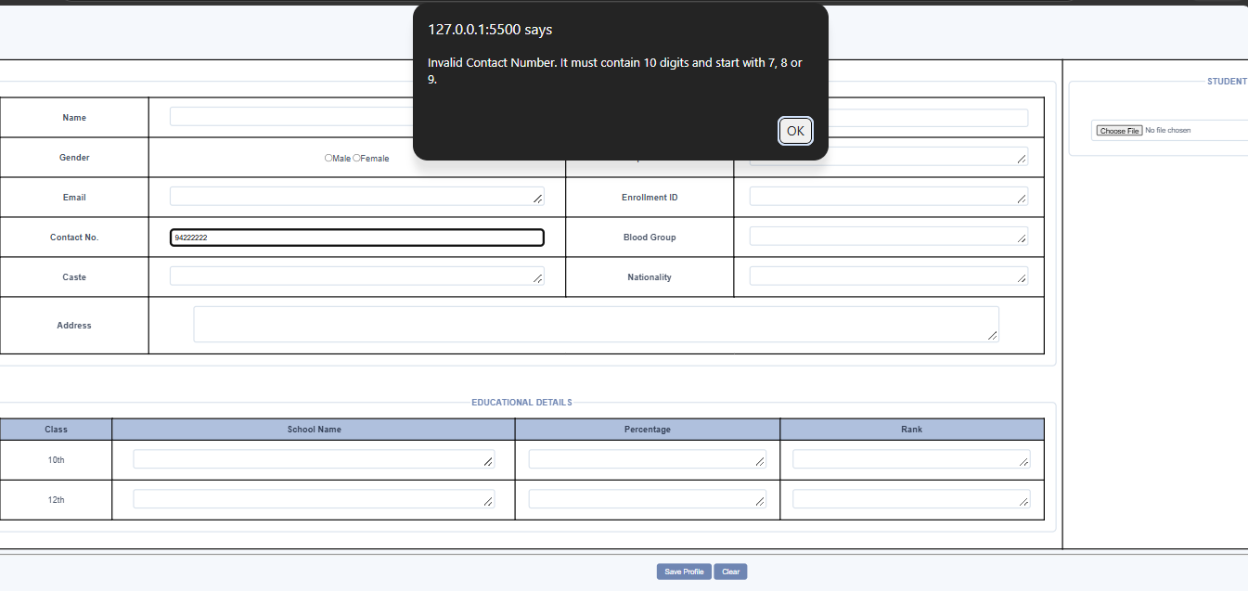

Successfully profile details of age and contact number is saved:
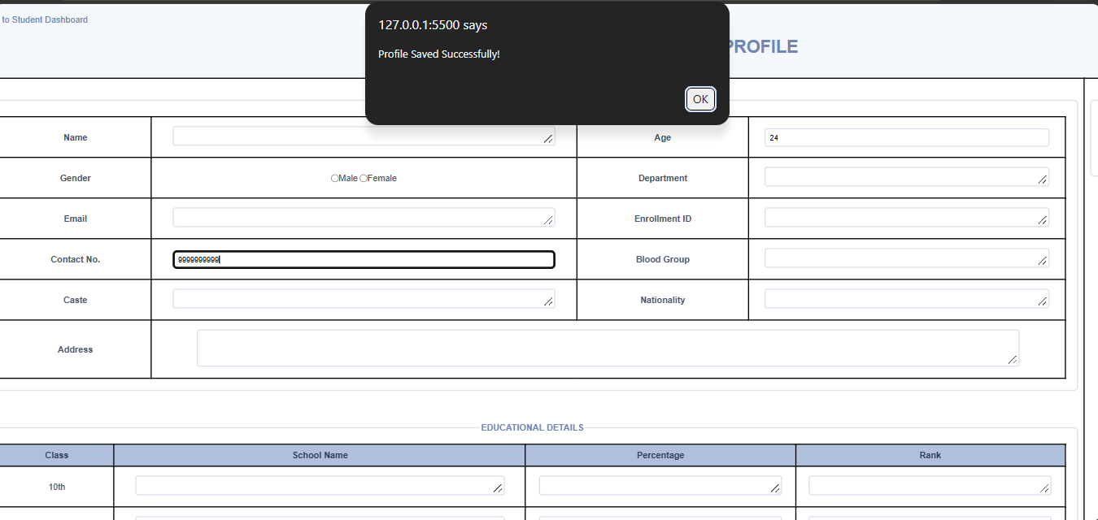

GitHub Repository Link:

https://github.com/shiloni28/WDF.git

E.Challenges Faced:

- Implementing password-strength validation with conditions for minimum length, uppercase, lowercase, and digits.
- Handling empty fields separately from incorrectly formatted fields.
- Handling empty and invalid inputs without allowing to get to proceed.
- Handling multiple validation conditions in the correct order, so that the user receives the appropriate error message.
- Providing user-friendly error messages so that users understand what needs to be corrected.

F.Learning Outcomes:
- Use regular expressions to validate Student ID, e-mail, age, contact number, and password.
- Implement password-strength validation based on specific requirements.
- Handle invalid inputs using conditional statements.
- Display user-friendly error messages using JavaScript.
- Test forms using valid and invalid test cases.
- Understand the importance of frontend validation and user experience.

Faculty Remarks:

